~~~~~~~~~~~~~~~~~~~~~~~~~~~~~~~~~~~~~~~~~~~~~~~~~~~~~~~~~~~~~~~~~~~~~~~~~~~

Running the following SQL commands, **This does not require a Snowflake virtual warehouse to be active.**

CREATE OR REPLACE DATABASE Production; USE DATABASE Production;

* **CREATE OR REPLACE DATABASE** is a metadata operation. Snowflake handles metadata operations (like creating databases, schemas, and tables) through its control plane, not the compute plane. **USE DATABASE** is just a session context change; it tells Snowflake which database to operate on next.

**When do you need a warehouse:** You need a virtual warehouse **only for operations that require compute**, such as:

* Running SELECT, INSERT, UPDATE, or DELETE statements
* Creating or modifying tables with data operations (e.g., copying data from files)
* Executing stored procedures or UDFs that involve data processing

~~~~~~~~~~~~~~~~~~~~~~~~~~~~~~~~~~~~~~~~~~~~~~~~~~~~~~~~~~~~~~~~~~~~~~~~~~~~~~~~~~~~~~~~~~~~~~~~~~~~~~~~~~~~

**Warehouse information will be displayed below, I can monitor by warehouse.**

select warehouse_name, cluster_number,

count(*) NBR_of_Queries,

sum(total_elapsed_time/1000) ELAPSED_TIME,

SUM(compilation_time) compilation_time_ms,

sum((queued_provisioning_time+queued_repair_time+queued_overload_time)/1000) queued_time_sec

from table(information_schema.query_history_by_warehouse('COMPUTE_WH'))

GROUP BY warehouse_name,cluster_number;

**We can see query text, which db running, query type, etc. Also we see if its long running queries, we will kill that. (TOTAL_ELAPSED_TIME), ERROR_MESSAGE,**

Select * from table(information_schema.query_history_by_warehouse(‘compute_wh’));

~~~~~~~~~~~~~~~~~~~~~~~~~~~~~~~~~~~~~~~~~~~~~~~~~~~~~~~~~~~~~~~~~~~~~~~~~~~~~~~~

*Stage the data files  
→Snowflake supports loading data from files that have been staged in either an internal (Snowflake) stage or external (Amazon S3, Google Cloud Storage, or Microsoft Azure) stage.  
In this tutorial, we will upload (stage) the sample data files to an internal table stage. The command used to stage files is PUT.*

**SnowSQL command line:**

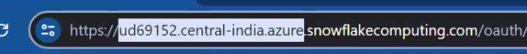> snowsql –version

> snowsql -a typeyoursnowflake identifier link

**It will ask username & password,**

**snowsql commandline will open:**

**now, there are 3 types of internal stages, user stage, table stage, named stage; we can use any stage and store our data;**

**To see files in user stage:**

**We are leveraging user_stage, copied files into user stage by using PUT command and leveraged COPY INTO to load data into tables.**

> list @~;

To copy data into user stage, use put command

> use warehouse compute_wh

> use role accountadmin;

> use warehouse compute_wh

> use ingest_data;

>create or replace table emp_basic(first_name string, last_name string, start_date date);

> show tables;

Now, we will load into this table from internal stage;

> put file://c:\temp\employee\employees0*.csv @~;

>list @~;

Copy data into target table

> copy into emp_basic from @~ file_format = (type = csv field_optionally_enclosed_by = ‘ “ ‘)

pattern = ‘.employee0[1-5].csv.gz’

on_error = ‘skip_file’;

> alter warehouse compute_wh resume;

> select * from emp_basic;

We can also use table_stage;

> list @%emp_basic;

> put file://c:\temp\employee\employees0*.csv @%emp_basic;

> copy into emp_basic from @%emp_basic file_format = (type = csv field_optionally_enclosed_by = ‘ “ ‘)

pattern = ‘.employee0[1-5].csv.gz’

on_error = ‘skip_file’;

Create NAMED_STAGE;

> create stage emp_stage;

> list @emp_stage;

> put file://c:\temp\employee\employees0*.csv @emp_stage;

> copy into emp_basic from @emp_stage file_format = (type = csv field_optionally_enclosed_by = ‘ “ ‘)

pattern = ‘.employee0[1-5].csv.gz’

on_error = ‘skip_file’;

Internal Stage – Loading JSON file

---Loading the JSON Data using Internal Stage

> CREATE OR REPLACE STAGE my_json_stage file_format = (type = json);

---Copy the JSON Data

> PUT file://c:\temp\family.json @my_json_stage;

> CREATE OR REPLACE TABLE relations_json_raw ( json_data_raw VARIANT

);

---Load the JSON Data

> COPY INTO relations_json_raw from @my_json_stage;

---Display the JSON Table

>SELECT

json_data_raw: Name,

json data raw:address,

VALUE: Name:: String,

VALUE: Relationship:: String

relations_json_raw

lateral flatten (input => json_data_raw:family_detail);

--Load Data into target table

--Now we have analyzed and extracted information. We can load the extracted data into the target table.

> CREATE OR REPLACE TABLE candidate_family_detail AS

SELECT json_data_raw:Name AS candidate_name;

VALUE:Name::String

VALUE:Relationship::String

FROM relations_json_raw, lateral flatten(input => json_data_raw:family_detail);

~~~~~~~~~~~~~~~~~~~~~~~~~~~~~~~~~~~~~~~~~~~~~~~~~~~~~~~~~~~~~~~~~~~~~~~~~~~~~~~~~~~~~~~~~~~~~~~~~~~

When use named stage, table stage, user stage

Share files with other ppl in team , if data is not much sensitive, If data is sensitive – use user stage.

When we use internal stages, when copy only once, when we don’t have cloud subscriptions.

If you store files in internal stages, storage cost is applicable. So once loaded remove the files, remove @stagename.

~~~~~~~~~~~~~~~~~~~~~~~~~~~~~~~~~~~~~~~~~~~~~~~~~~~~~~~~~~~~~~~~~~~~~~~~~~~~~~~~~~~~~~~~~~~~~~~~~~~~~

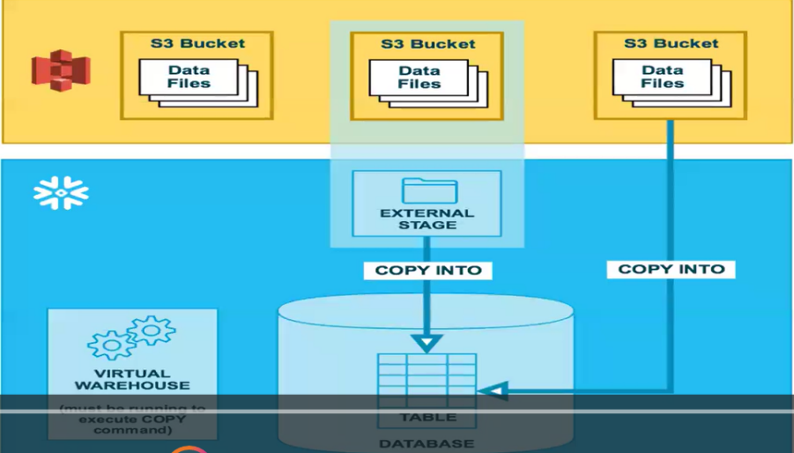

> We first establish connections between S3 bucket and External Stage.

> Once files are into external stage, as regular process files will load into table.

> In internal stage we need to have files available, then using copy into command load into tables.

We will establish connection between S3 Bucket and Snowflake location. For this we will create external stage.

As soon files are loaded into external stages, as regular process we will use copy into command to load files into respective tables. It will pickup files and load into tables.

There are sequence of steps: